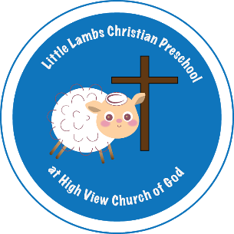

2470 Leaman Rd. Ronks, PA 17572
(717) 687-0523 www.hvcog.org
E-mail: littlelambsks3@gmail.com

Dear Parents,

Thank you for your interest in Little Lambs Christian Preschool! Registration is open to current families and church members beginning January 2, 2026. Registration is open to the community beginning January 15, 2026. Registration is on a first-come, first-served basis.

Enclosed you will find the form necessary for enrollment. To enroll your child:

- Please mail the completed form and the registration fee of $50.00 per child/$80 max per family (payable to Little Lambs) to the address above (Attention: Kerri Thompson).
- Classes are filled on a first-come, first-served basis. THE REGISTRATION FEE MUST BE PAID TO ENSURE YOUR CHILD’S ENROLLMENT. *REGISTRATION FEES ARE NON-REFUNDABLE.
- A discount is available for families with 3 or more children enrolled.
- SCHOLARSHIP INFORMATION IS AVAILABLE UPON REQUEST.

Tuition may be paid all at once or in 8 monthly payments (September thru April). A 5% discount is given when payment for the year is made on or before AUGUST 15, 2026. Any payment after this time will not be eligible for the discount.

At Little Lambs Christian Preschool, we strive to provide the finest in early childhood Christian education. We believe that each child is a unique gift from God to be cared for and encouraged to reach his/her potential in all aspects of life.

Thank you for considering sharing your child with us.

Kerri Thompson
Preschool Director

We offer the following classes taught by a PA Certified Teacher:

Pre-K Class - For children who are 4 years of age by September 1. Children must be potty trained to attend. Class size for each option is limited to 14 children.

OPTION #1: A two day morning class that meets on M & W from 9:00 a.m. – 11:30 a.m.
Tuition for this class is 800.00 ($100.00 per month).

OPTION #2: Add a third morning (Fridays) from 9:00 a.m. – 11:30 a.m.
Tuition for the three day class is $1,200.00 ($150.00 per month).

OPTION #3: A two day afternoon class that meets on M & W from 12:30 p.m. – 3:00 p.m.
Tuition for this class is 800.00 ($100.00 per month).

3 Year Old Class - For children who are 3 years of age by September 1. Children must be potty trained to attend. Class size is limited to 12 children.

OPTION #1: A two day morning class that meets on T & TH from 9:00 a.m. – 11:30 a.m.
Tuition for this class is $800.00 ($100.00 per month).

We also offer a 2 Year Playgroup:

2 Year Playgroup - For children who are 2 years of age by September 1. Class size is limited to 6 children.

OPTION #1: A two day morning class that meets on M & W from 9:00 a.m. – 11:30 a.m.
Tuition for this class is $850.00 ($106.25 per month).

